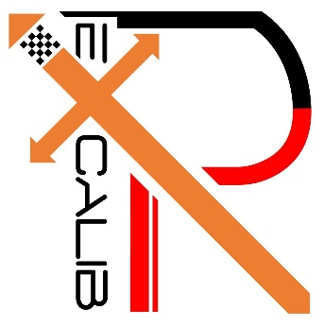

**16-682 - MRSD Project II | ILR #06**

**Individual Lab Report #06 |February 02, 2017**

**SAMBUDDHA SARKAR**

**Team G**

**eXcalibR**

Huan-Yang Chang

Man-ning Chen

Sambuddha Sarkar

Siddharth Raina

Yiqing Cai

**1. INDIVIDUAL PROGRESS**

1.1 Overview

In this ILR I would describe the design process of a 2 camera virtual scene with on calibration target. The virtual environment is being modeled in an open source platform: Blender 3D 7.68a. It is a Maya based platform and is programmable by Python 3.

Topics covered have been listed below for a quick overview.

1.2 Calibration Target Mesh Model: Icosahedron

1.3 Calibration Target Mesh Texture: UV Unwrapping

1.4 Lighting of Environment

1.5 Camera Setup (2)

1.2 Calibration Target Mesh Model: Icosahedron

Using the model editor, the mesh model of the Icosahedron was created in Blender 3D. The mesh model of the required dimension has been shown if Fig. 1.2.1; This mesh model was then covered with faces created from the vertices of the model. The convergence was parabolic so the model has sharp edges as it would have in the real world and not razor sharp as a computer generated model generally have. The surfaced model is shown in Fig. 1.2.2.

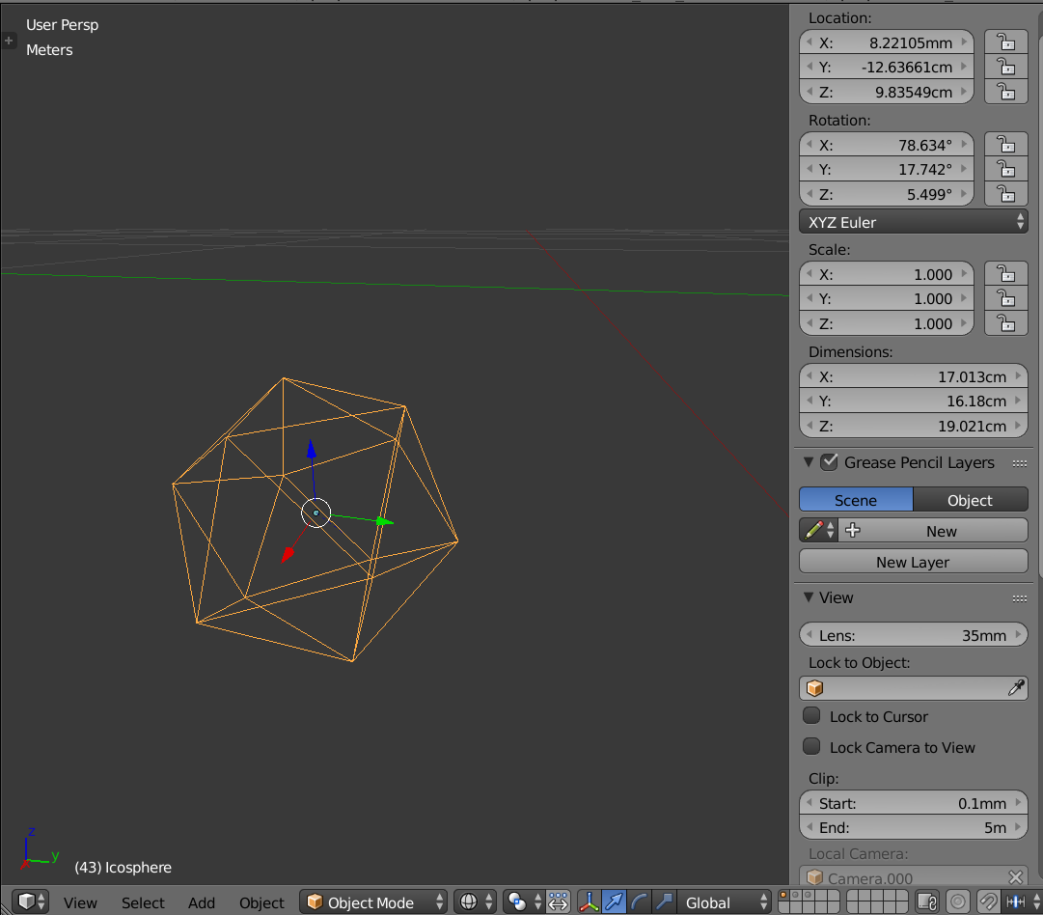

Fig. 1.2.1, Mesh Model of the Icosahedron

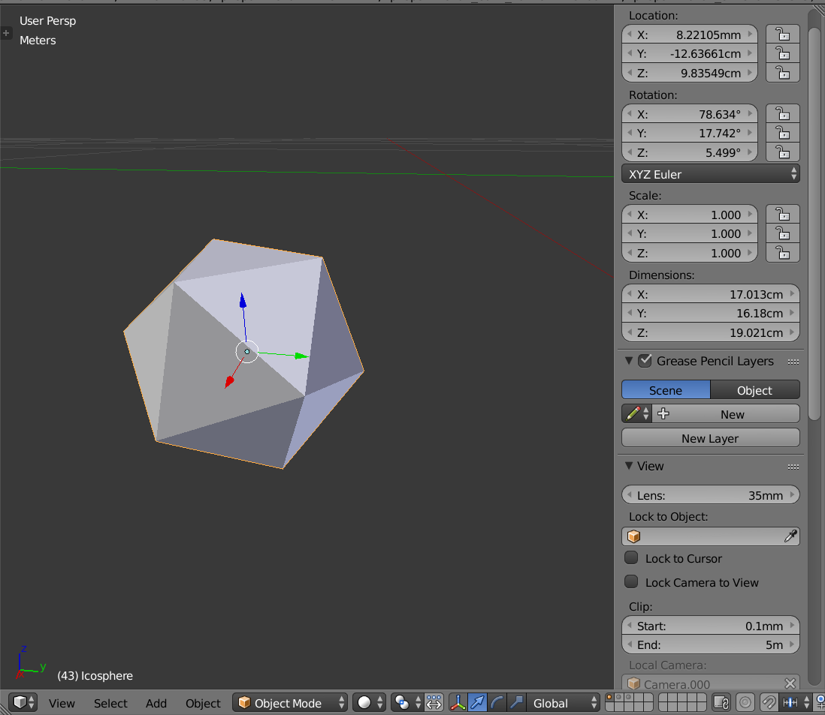

Fig. 1.2.2, Surfaced Model of the Icosahedron

1.3 Calibration Target Mesh Texture: UV Unwrapping

The target pattern has to be imprinted onto the 3D model of the calibration target. This is achieved using a feature known as UV unwrapping in 3D modeling. Here we split the image into an unwrap pattern (Fig 1.3.1) and this unwrapped pattern is mapped onto the 3D object in the environment (Fig. 1.3.3). The orientation of the faces on the calibration target is very specific and this has to mapped exactly to the designated vertices of the Icosahedron. The pattern has to digitally mapped with sub-pixel precision (Fig. 1.3.2). Paper bump map has been applied through the surface of the target.

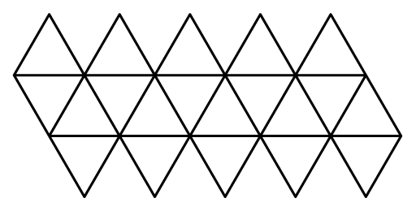

Fig. 1.3.1, Unwrapping Style.

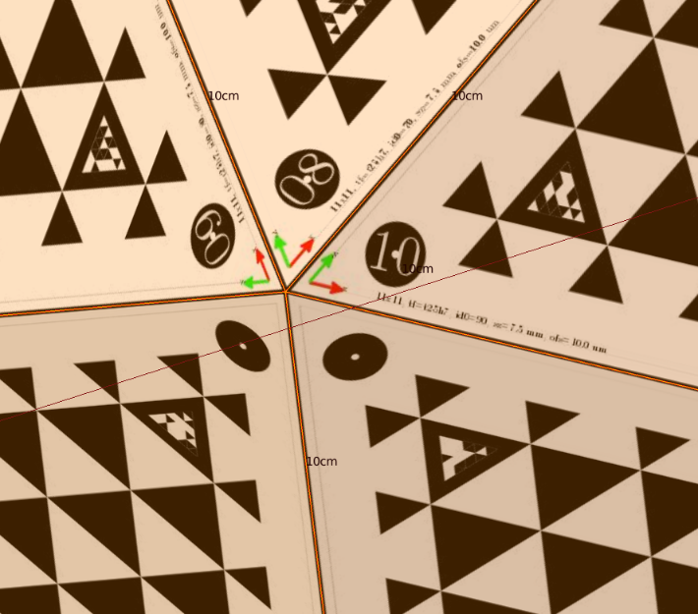

Fig. 1.3.2, Sub-pixel overlay accuracy.

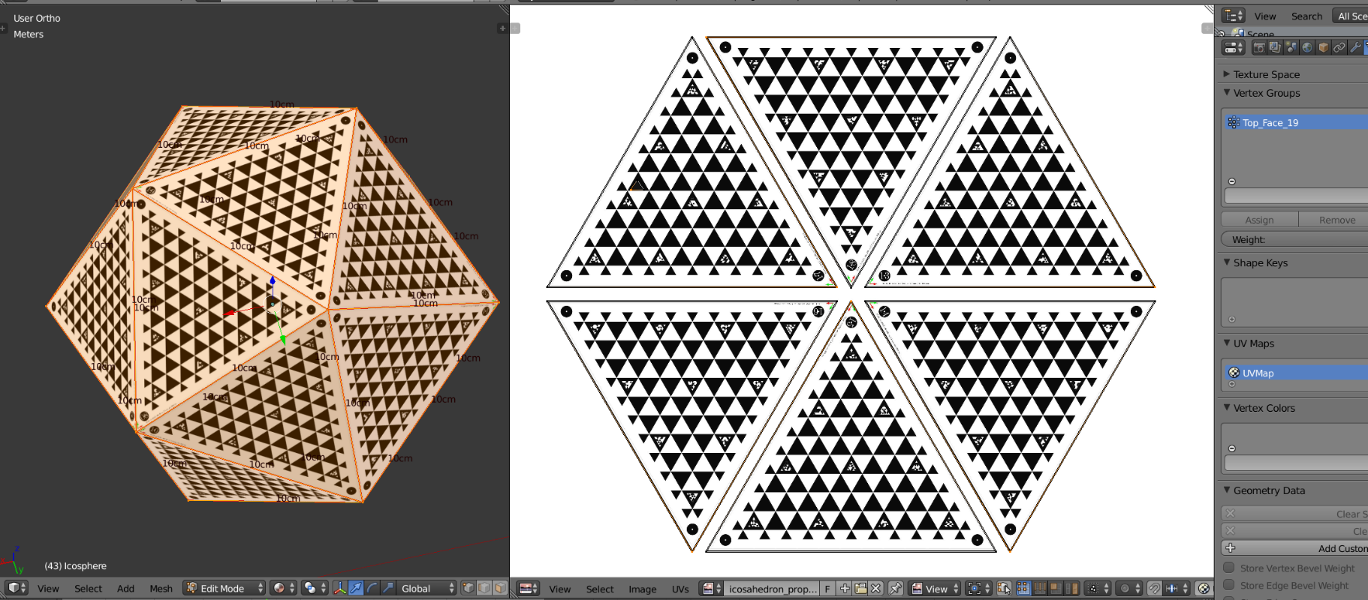

Fig. 1.3.3, UV Mapping of the pattern layout onto the calibration target.

1.4 Lighting of Environment

The lighting for now has been achieved using a simple “SUN” model whereby the whole environment is bathed in uniform light with no specularity. (specular: the property which dictates the sheen/shine factor of a surface).

1.5 Camera Setup (2)

The setup being tested now is a 2 camera setup. These cameras as virtual cameras setup with the specifications of the physical cameras that we have. The extrinsics are design compliant but not fixed for the preliminary stages. Figure. 1.5.1 shows the visual representation of the cameras with respect to the calibration target. The size of cameras in the depiction are not scaled.

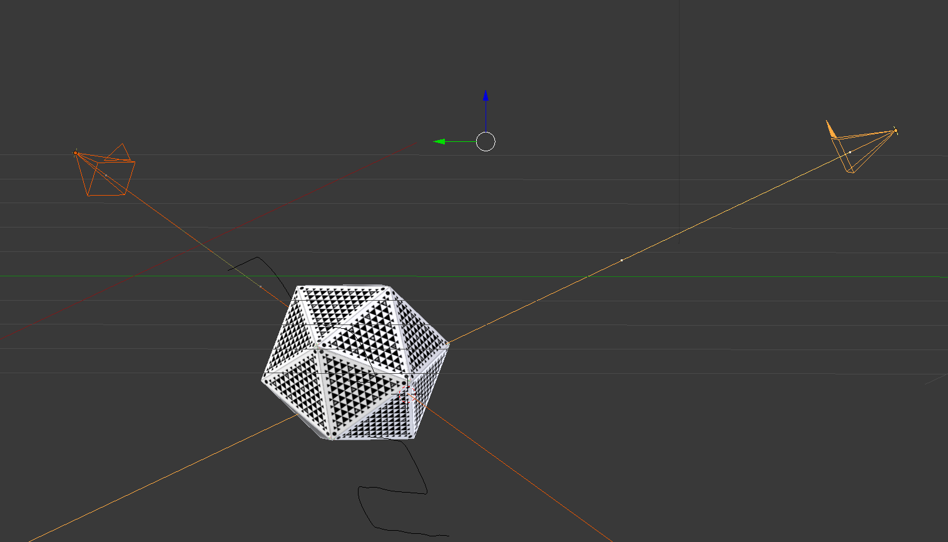

Fig. 1.5.1, 2 Camera Scene

**2. CHALLENGES**

There were no challenges yet. But as the number of Cameras in the scene will increase, challenges in computational power can be expected in the future.

**3. TEAM WORK**

The project work was divided among the team members and the task was assigned according to the strengths of the team members. The task division has been listed below in Table 3. The divided tasks can be completed in parallel; hence others can pitch in when some team members fall behind in their work.

|  |  |
| --- | --- |
| **Team Member** | **Task** |
| Huan-Yang Chang | Familiarization with ABB Robot Studio. |
| Siddarth Raina | Literature review on sensor noise types and correction techniques. |
| Man-nig Chen | Color Calibration: Blob detection using intensity segmentation. |
| Yiqing Cai | Multiple Camera Model: Extrinsics & Instrinsics Modeling. |
| Sambuddha Sarkar | Modelling 2 Camera scene using Blender 3D |

Table 3, Task Division.

**4. FUTURE PLANS**

My future plans until the next progress report is model the intrinsics of the cameras and validate the same. I would be generating a set of images from both the cameras by making the calibration target traverse a trajectory in the virtual environment. Exporting geometric data from Blender scene into a “.txt” or “.csv” format will be an expected outcome by the next progress review.

**5. BONUS: IMAGE RENDER SAMPLES**

**It’s not an exact science when it comes to getting photo-realism. It is more of an art form. I am kind of proud of my results, please do have a look below.**

